-- SQL PROJECT

use prj;

show tables;

select * from olympics;

-- 1. Show how many medal counts present for entire data

select count(medal) as total_medal_count from olympics;

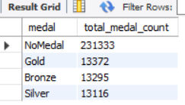

-- 2. Show count of unique sports present in Olympics

select count(distinct sport) as count_distinct_sports from olympics;

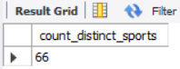

-- 3. Show how many different medals won by team India

select team, medal, count(medal) as medals_count from olympics

where team="India" and medal!="NoMedal"

group by medal;

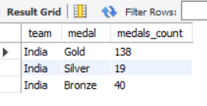

select * from olympics;

-- 4. Show event wise medals won by India show from highest to lowest medals won in order

select event, team, medal, COUNT(medal) AS total_medals

from olympics

where team = 'India' and medal!="NoMedal"

group by event, team, medal

order by total_medals DESC;

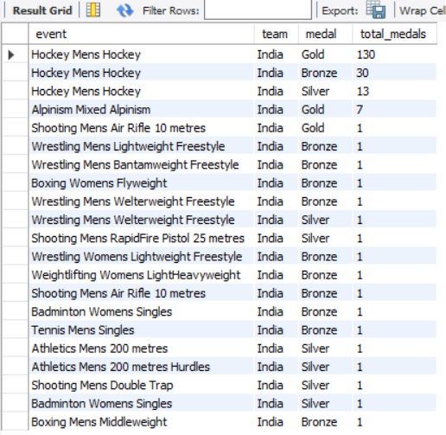

-- 5. Show event wise medals won by India in order of year

select event, year, medal, team from olympics

where team="india" and medal!= "NoMedal"

group by event, year, team, medal

order by year;

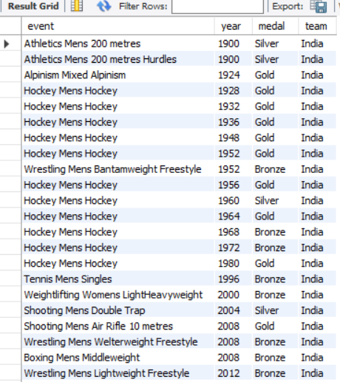

-- 6. show country who won maximum medals.

select team, count(medal) as total_medals

from Olympics

where medal!= "NoMedal"

group by team

order by total_medals desc

limit 1;

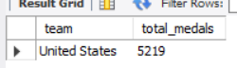

-- 7.show top 10 countries whowon gold

select team, count(medal) as gold_medals

from olympics

where medal="Gold"

group by team

order by Gold_medals desc

limit 10;

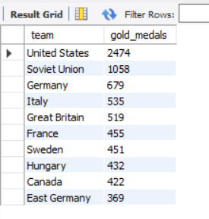

-- 8. show in which year did United states won most gold medal

select year, COUNT(medal) AS gold_medals

from olympics

where team = 'United States' and medal = 'gold'

group by year

order by gold_medals DESC

limit 1;

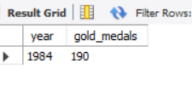

-- 9. In which sports United States has most medals.

select sport, COUNT(medal) AS total_medals

from olympics

where team = 'United States' and medal!= "NoMedal"

group by sport

order by total_medals DESC

limit 1;

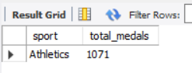

select * from olympics;

-- 10. Find top three players who won most medals along with their sports and country

select name, team, COUNT(medal) AS total_medals

from Olympics

where medal!= "NoMedal"

group by name, team

order by total_medals DESC

limit 3;

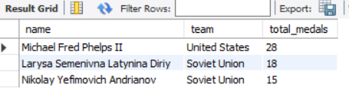

-- 11. Find player with most gold medals in cycling along with his country.

select name, team, COUNT(medal) AS gold_medals

from olympics

where medal="gold" and sport="cycling"

group by name, team

order by gold_medals DESC

Limit 1;

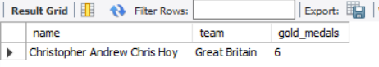

-- 12.Find player with most medals (Gold+Silver+Bronze) in Basketball also show his country.

select name, team, COUNT(medal) AS total_medals

from olympics

where sport="basketball"

group by name, team

order by total_medals DESC

limit 1;

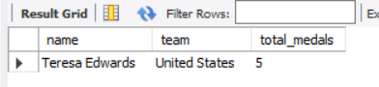

-- 13. Find out the count of different medals of the top basketball player Teresa Edwards

select medal, count(medal) as medal_count

from olympics

where name="teresa edwards"

group by medal;

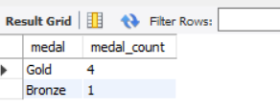

select * from olympics;

-- 14. Find out medals won by male,female each year , Export this data and plot graph in excel

select year, sex, COUNT(medal) AS medal_count

from olympics

where medal!="Nomedal"

group by year, sex

order by year;

